Assambly Instructions - 2.0.1
Auto Slider - 2.1.0
AwaLabs Case Form - 2.1.0
AwaLabs File Upload - 2.1.0
Back In Stock Notification - 2.0.1

Blog - 2.1.1
Bulb Upsell - 2.1.1
Cart Availability and BIS Date - 1.0.0
Cart To Quote - 2.1.0
Case Custom - 2.1.0
Categories Custom Sort - 2.1.0
Categories Facets Display Feature - 1.1.0
Checkout Credit Cards Views - 2.1.0

Checkout Improvements - 2.1.1
Checkout Steps - 2.0.0
CMS Merchandising Zones Initialization - 1.0.1
Contact Us Logged In - 2.1.0
Core Content Extension - 1.0.6

Credit Card Error - 2.0.0
Custom Fields - 1.1.4
Default Addresses - 2.1.0
Delivery Instructions - 2.1.0
Dialog - 2.0.0
Faceted Items Dynamic Height - 1.0.0
Dynamic Merchandising Zones - 2.0.0
Exclude From SEO - 1.0.0

Expected Ship Date - 1.0.0
Facets Settings - 2.1.0
Favicon fantasy - 2.0.0
Favorites List - 2.1.0
Footer Copyright - 2.1.0

Foursixty - 1.0.0
Geo IP Location - 2.1.0
Head Content By Application - 2.1.0
Header Customizations - 2.0.0
Hide Edit Shipping Address - 1.0.0
Hide Shopping Sections - 1.0.0
Image Switcher - 1.0.0

Inactivity Message - 2.1.0
Horizontal Facets - 1.0.0
Inventory Display - 1.2.8
Inventory Display Fix - 2.0.1
Item Badges - 1.1.5
Item Options - 2.0.0
Item Search Auto-Add - 2.1.0
Jewelry - 2.1.1
Klaviyo - 3.0.7

Class for landings - 2.0.0
Login Register Trade - 2.1.0
Map & Contact - 1.1.6
Newsletter Config - 2.0.0
Newsletter Sign Up - 1.1.3
Ordered By - 2.1.0
Order Status - 1.0.4
Order Status Improvements - 2.0.0
Order Status Improvements Handlebars Extras - 2.0.0
Order Wizard Module Cart Summary HideTax - 2.0.0

Outer CSS - 1.0.0
PDF Generator - 1.0.1
PDP Custom Fields - 2.2.0
Photo Gallery - 1.2.1
Product Listing Page Color Relations - 2.0.0
Price Toggle - 2.1.1
PLP Cell Content - 1.0.0
Product Gallery Addons - 2.0.0

Profile Utils - 2.0.1
Redirect After Login - 1.0.0
Remove Default Ship Method - 1.0.0
SchemaOrg - 2.1.0
SEO Enhancements - 1.0.4
SEO Improvements - 2.0.0
Set Default Address - 1.0.0
Show All Transactions - 1.0.0
Slideshow - 1.0.3

Social Media - 2.1.0
Sort Shiping Methods - 1.0.0
Sticky Header - 2.0.0
Social Share Language - 1.0.0
Stock Notifications - 1.1.8
StoreLocator - 2.0.0
Terms And Conditions Mandatory - 2.0.0
Tracking Numbers - 1.1.0
Trade - 2.1.0
WasPrice - 1.0.0

Activar theme regina Andrews.
Activar recognized and logged in customers.
Quitar esta regla: 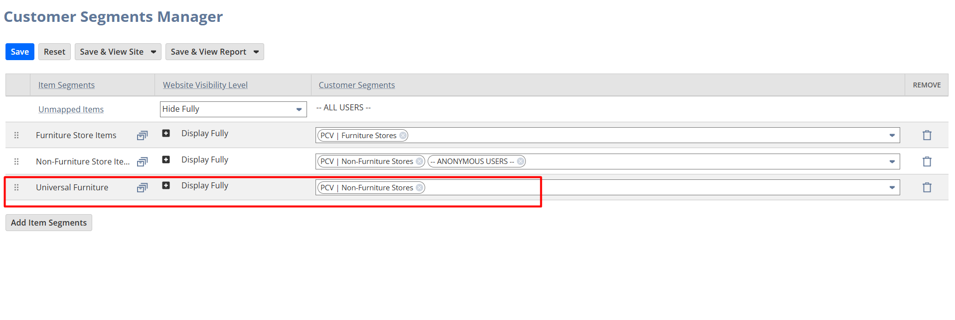

Rebuild del index search:
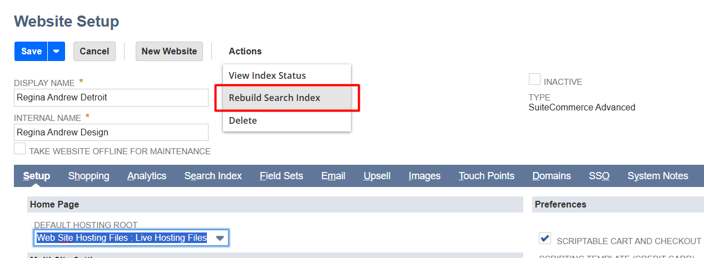

Modifique la search:
https://1283670-sb2.app.netsuite.com/app/common/search/search.nl?cu=T&e=T&id=159598
Revertir el does not contain name Bowen

